Q10

2247207

Akshaya Agarwal

from tkinter import *

import tkinter as tk

#defining the function

total = 0

def selection():

global total

number_of_hours = E1.get()

type_of_vehicle = var.get()

if type_of_vehicle == 1:

amount = float(number_of_hours) * 100

elif type_of_vehicle == 2:

amount = float(number_of_hours) * 200

text = f"Please collect rs. {amount}"

L3 = tk.Label(win, text=text, bg='grey', font=('Arial', 15))

L3.place(x=80,y=240)

#displaying total amount

total = total + amount

ftext = f"Total collection: {total}"

L4 = tk.Label(win, text=ftext, bg='grey', font=('Arial', 10))

L4.place(x=350,y=280)

#creating an instance

win = tk.Tk()

win.geometry("500x300")

win.config(bg='grey')

Heading = tk.Label(win, text="Parking Fees Calculator", bg='grey', font=("Arial", 20))

L1 = tk.Label(win, text="Select Type of Vehicle: ", bg='grey',font=("Arial", 13))

var = IntVar()

R1 = Radiobutton(win, text="2 Wheeler", variable=var, value=1, bg='grey')

R2 = Radiobutton(win, text="4 Wheeler", variable=var, value=2, bg='grey')

L2 = tk.Label(win, text="Number of hours:", bg='grey', font=("Arial",13))

E1 = tk.Entry(win, bd=5)

Register = tk.Button(win, text="Calculate", command=lambda: selection(), bg='black', fg='white', pady=10, padx=80)

#defining placement of elements

Heading.place(x=80, y=20)

L1.place(x=30,y=80)

R1.place(x=230, y=80)

R2.place(x=330, y=80)

L2.place(x=30, y=120)

E1.place(x=250, y=120)

Register.place(x=150,y=170)

win.mainloop()

OUTPUT:

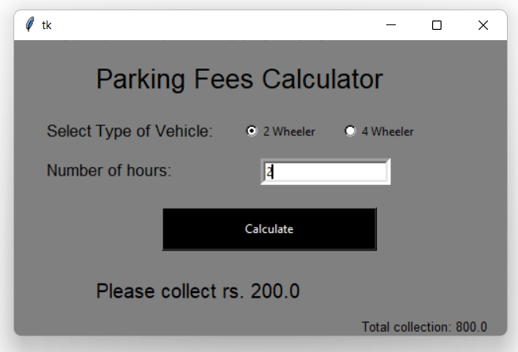

Total collection tell about the total amount that is collected for the whole day.